**10.4: OBJECTIVE ASSESSMENT**

* Vital signs including physical examination and observation for nonverbal response to pain.

Behavioral effects

* Assess the verbalization, vocal response, facial and body movements and social interactions.
* Facial expression is often the 1st indication of pain and may be only one manifestation.
* Clenched teeth, tightly shot eyes, open somber eyes, biting of lower lips and other facial grimace may be indicative of pain.
* Vocalization like moaning, groaning, crying, grunting, screaming, are associated with pain.
* Aggressive or disruptive behavior, inappropriate behavior, decreased interaction.
* Cognitive decline, increased confusion, irritability or distress.

Physiological Response

* Physiological responses vary with the origin and duration of the pain. Early in the onset of acute pain, the sympathetic nervous system is stimulated, resulting in increased blood pressure, pulse rate, respiration, pallor, diaphoresis, and pupil dilation.

**10.5: PAIN MANAGEMENT TECHINQUES**

**THERAPEUTIC MEASURES TO RELIEVE PAIN**

* The nature of pain and the extent to which if affects a person's wellbeing determine the choice of pain relief interventions.
* Pain therapy requires individualized approach.
* The nurse, the client and the family must be partners in using pain control measures.
* Generally, the least invasive or safest therapy should be tried first.
* Teaching clients about the pain experience reduces anxiety and helps clients achieve a sense of control.
* When a person develops pain or other symptoms of discomfort, there are non- pharmacological as well as the pharmacological strategies to be offered

Different types of interventions (pharmacological and /or non- pharmacological) are used for pain relief with the following purposes:

* To alleviate or decrease pain.
* To increase function.
* To improve the quality of life.

**TYPES OF PAIN MANAGEMENT TECHNIQUE**

* Pharmacological Pain Management
* Non-Pharmacological Pain Management

**PHARMACOLOGICAL PAIN RELIEF INTERVENTIONS**

* There are several pharmacological agents for acute and several pain that provide pain relief and require a physician's order to administer. The nurse's judgment in the use and management of these medication help ensure the best pain relief possible.
* **Analgesic**
* NSAIDs
* Opioids
* Adjuvants

**1. NSAIDS Including Acetylated Salicylates (ASA)**

* NSAIDs are anti- inflammatory through their ability to inhibit the enzyme cyclooxygenase that catalyzes the conversion of arachidonic acid to prostaglandins and leukotrienes.
* Their effect is to decrease the levels of these inflammatory mediators that sensitize nerve endings to painful stimuli.
* Because analgesic from NSAIDs is achieved through a different mechanism from the opioids and other adjuvants analgesics, they may be combined with these drugs to achieve at lower better pain relief than with a single drug alone.
* The side effects of the NSAIDs are related to their mechanism of action. Inhibition of cyclooxygenase leads to inhibition of platelets aggregation, decreased cytoprotection in the gastric mucosa, and decreased renal perfusion. Consequently, bleeding and renal function are important side effects.
* The non- acetylated salicylates (choline magnesium Tri salicylate and salicylate) do not significantly affect platelet aggregation. They may be useful in patients who are thrombocytopenic and for whom other NSAIDs are contraindicated.
* In contrast with the opioids, the NSAIDs and acetaminophens have a ceiling (maximum) effect to their analgesic potential, do not produce pharmacological tolerance, and are not associated with physical or psychological dependence.

**2. Opioids**

* Opioids analgesics act by binding to opioids receptors of three subtypes (mu, kappa, and delta).
* The opioid analgesics in common usage may be divided into those which are fully pure agonists, partial agonists and mixed agonist - antagonists.
* The pure agonist drugs Meperidine (Demerol), morphine are the most useful in chronic intractable pain, are safe and effective in geriatrics populations for chronic pain conditions other than cancer.
* The mixed agonists- antagonist’s opioids (such as pentazocine, butorphanol and nalbuphine) and the partial agonist opioids (such as buprenorphine) are poor choices for patients with severe pain.

Routes of administration

* The preferred route for analgesic administration for the management of pain is oral. This route provides the simplest, least expensive way to manage up to 90 percent of all cancer pain.
* When the oral route is not available, analgesic can be administered buccally and rectally without resorting to more expensive and invasive routes of delivery.
* In some patients, subcutaneous, intravenous, or intraspinal administration may be required.

**3.Adjuvant Pain Medicine**

* Adjuvant analgesics are drugs used to enhance the analgesics efficacy of opioids, treat concurrent symptoms that exacerbate pain, and/ or provide independent analgesia for specific types of pain.
* Some of the adjuvants, such as acetaminophen, the corticosteroid, the tricyclic antidepressants and anti-epileptics have primary analgesic activity themselves and may be used alone as a coanalgesics.
* Bone pain from bone metastases is thought to be, in part, prostaglandin mediated. Consequently, the NSAIDs and /or steroids may be particularly helpful in combination with opioids.
* Neuropathic pain is rarely controlled with opioids alone. The tricyclic antidepressants, antiepileptics and steroids are often required in combination with the opioids to achieve adequate relief, NSAIDs and/or acetaminophen may be added to the opioids for adjuvant analgesia, particularly when inflammatory or peripheral mechanisms are thought to be responsible for the painful stimulus.

**a. Acetaminophen:**

* Although it is analgesics and antipyretics, it is not anti- inflammatory.
* Its analgesic activity is at least additive to other analgesic agents, including the NSAIDs and opioids.
* Acetaminophen is associated with significant liver toxicity.
* It is generally recommended that the total doses not exceed 4 grams per 24 hours.

**b. Corticosteroids:**

* Provide a range of effects including anti- inflammatory activity, mood elevation, antiemetic activity and appetite stimulation.
* They reduce pain both by their anti- inflammatory effects of reducing arachidonic acid release to form prostaglandins as well as decreasing swelling and pressure on nerve ending.

**c. Anticonvulsants**

* Such as carbamazepine, valproate, clonazepam, and gabapentin are used either alone, or addition to opioids or other co analgesic to manage neuropathic pain. They have been particularly advocated for neuropathic pain with a shooting or lancinating quality (such as trigeminal neuralgia or nerve root compression.

**d. Tricyclic Antidepressants:**

* (Such as amitriptyline, desipramine, imipramine, nortriptyline) are useful in pain management in general, neuropathic pain in particular. They have innated analgesic properties and are effective through mechanisms that include enhanced inhibitory modulation of nociceptive impulses at the level of the dorsal horn.

**e. Bisphosphonates**

* (Such as pamidronate) and calcitonin have been used as adjuvant analgesics in the management of bone pain from bone metastases. In cancer, bone pain is caused in large part by osteoclast- induced bone reabsorption rather than the direct effects of the tumor on periosteal or medullary nerve endings. Both the bisphosphonates and calcitonin inhibit osteoclast activity on bone and have been reported to reduce pain significantly in at least some patients.

**WHO ANALGESIC LADDER FOR PAIN MANAGEMENT**

1. Non- opioids- NSAIDs, Paracetamol
2. Weak opioids -Codeine, tramadol
3. Strong opioids- morphine, Pethidine, buprenorphine
4. Adjuvants-

* Anxiolytics- Diazepam, Alprazolam
* Antidepressants - Amitriptyline
* Corticosteroids- Prednisolone, Dexamethasone

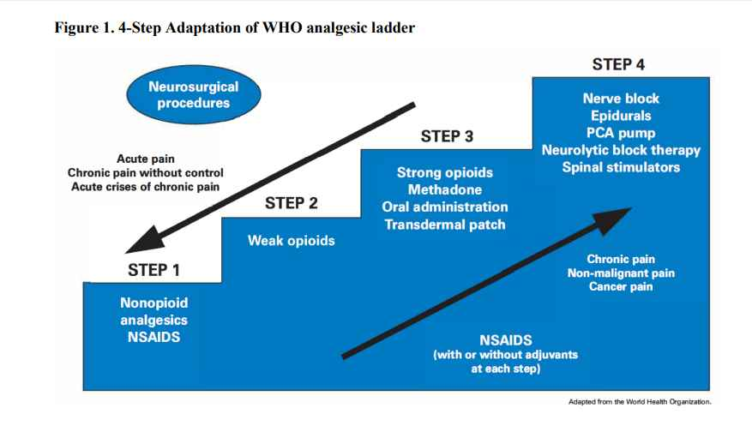

* Step One
* Acetaminophen and the non- steroidal anti -inflammatory drugs (NSAIDs) including acetylsalicylic acid (ASA) is the mainstay of step one of the WHO analgesic ladder for the management of mild pain. They may be dosed up to recommended maximums. Many are available without prescription.
* Step Two
* Several opioids’ analgesics are available in combination with either acetaminophen or ASA are commonly used to manage moderate pain.
* Propoxyphene, tramadol and codeine have been termed "weak" opioids because, in combination, they have a ceiling to their analgesic potential due to the maximum amounts of acetaminophen or ASA that can be administered per 24 hours. (i.e. 4gm acetaminophen per 24 hours)
* They may be dosed up to recommended maximums.
* If pain persists, or increases, despite a maximum dose of a step two drug, a step three drugs should be prescribed instead.
* Step Three
* The pure agonist opioids analgesics comprise step of the WHO analgesic ladder.
* Morphine is the prototypical drugs because of its ease of administration and wide availability.
* Many patients with chronic pain are best managed with an appropriately strong opioids that is combined with one or more co - analgesics.
* In contrast with the step- one and step-2 analgesics, there is no ceiling effect or upper limit to the dose of opioids to relieve pain.
* Step Four
* Several studies of the WHO 3- step ladder have demonstrated that its application results in the adequate control of up to 90% of patients with cancer pain.
* Several authors have informally invoked "step four" to indicate approaches that should be reversed for patients whose pain is not controlled by competent use of the analgesic approaches outlined in the first three steps.
* Intraspinal administration of opioids analgesics either epidurally or intrathecally may be required in selected patients. Neuroablative techniques such as peripheral neurolytic blockade, ganglionic blockade, and cingulotomy may be appropriate in highly selected patients

**METHODS AND ROUTE OF DRUG ADMINISTRATION**

1. Patient - controlled analgesia (PCA):

* It is a drug delivery system that allow client to safe administer opioids with minimal risk of overdose. The goal is to maintain a constant plasma level of analgesic. A safe method for post- operative and cancer pain management that most patient prefers.

b) Local analgesic infusion pump to avoid systemic effect of oral analgesics following orthopedic surgery through catheter from the attached with a pump containing local anesthetics.

c) Topical analgesic and anesthetics: EMLA (eutectic mixture of local anesthesia) I/V site, Lidoderm patch - cutaneous neuropathic pain.

d) Local anesthesia- inhibit nerve conduction

e) Regional anesthesia: epidural anesthesia, pudendal block, spinal anesthesia

**NURSING PRINCIPLE FOR ADMINISTRATING ANALGESICS**

1. Know the client’s previous response to analgesics:

* Allergies, risk factors for example, history of sleep apnea.
* Previous dose and routes- to avoid under treatment.
* Whether relief was obtained.
* Effectiveness- opioids / non - opioids

2. Select proper medications when more than one is ordered:

* Use monopod analgesics or opioid combination drugs for mild- moderate pain.
* Know that nonopioids can be given with opioids.
* In older adults, avoid combination of opioids.
* Remember that morphine and hydromorphine are the opioids of choice for long -term management of severe pain
* Know that intravenous medications act quicker and can relieve severe acute pain within 1 hour, oral within 2 hour.
* Understand that I/M analgesics for severe pain because such combinations treat pain peripherally and centrally.

3. Know the accurate doses- adjust doses

4. Assess the right time and interval for administration for example before increases severity, around the clock is the best, before pain producing procedures.